To B or Not

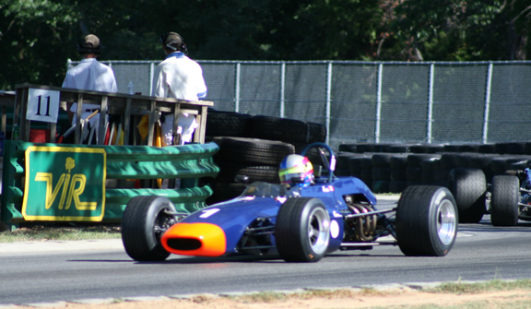
I have been seriously considering going vintage racing for a couple of years now. Since SCCA has changed the end of the season prize into a trip to Topeka, Kansas, I have abandoned running a national race schedule. Much of the appeal of SCCA racing has evaporated. I need a change.
Travis Engen, Chevron B17

I have raced a D SportsRacer for the past 11 seasons. Class has been great with the cars going faster every year, thanks mostly to the escalation of applied engineering by the Japanese sport bike manufacturers. Crashed sport bikes provide donor motors for our sportsracers. Also recently, DSR chassis builders have significantly raised the bar of performance, mostly due to aero improvements. Engineering progress has come with a relatively large increment in cost. Plan to spend $75K on a front running car and sleep restlessly knowing it could be obsolete/uncompetitive tomorrow.

So, I have been going to a few vintage races and doing my due diligence. At first, my main concern was which class to embrace. Having raced formula cars for several decades starting in 1965, they had appeal. Having raced a sportsracer for a long time, I have come to hate acres of fiberglass to be repaired and maintained. Most of the formula cars fall under the Monoposto rules structure that is followed by most vintage racing organizations in the USA and the UK. The pre 1972 Formula Fords are a popular class with attractive cars of the classic cigar shape. Although the costs are reasonable, I have been going so much faster in my DSR for so long now, they did not appeal to me. Plus, long ago in my FF days, I learned to hate the fragile Kent FF motor.

When I started racing in 1965 with a lowly FV, the Formula B cars were the hot, fast, and sexy cars. Add some current safety improvements, they could the ticket. Yea, and great marques such a Lotus, Brabham, and Chevron can be found and are being vintage raced in growing numbers. The Brabham BT29 was the killer car of 1969 as well as drop dead beautiful. (Roll the James Garner Grand Prix footage.) Thus, I quickly converged.

I spent the day at the SVRA meet at Virginia International Raceway (www.virclub.com) with the purpose of interviewing some FB owners/drivers. There were seven Brabhams and one Chevron on the entry list. I talked with lots of people including the owners of several mid 70’s era FA/F2 cars that ran in the “slicks and wings” group. I learned a lot.
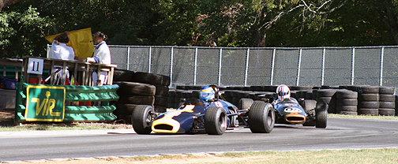
Marc Giroux, BT29 leads Mark Harmer, BT2

Consensus:

- How long have you been doing FB? Past 7 or 8 years. For a couple of guys, this was their first ever racecar.
- Strengths of class? Fast, very forgiving and beautiful cars. Size of fields of competitors is growing and the top 4 or 5 guys are very close in speed. Cars do appreciate in value.
- Minus? Cost of tires and engine rebuilds. Tires are Avon slicks that are hand grooved. (Grooved tires are required by the rules). Cost is $1300 per set. Life is one to three race meets depending upon whether you have a huge tow rig or a modest trailer. Engines get rebuilt at least once per season (10 to 15 hours) at $4k-$5k. Cost of a new engine is $20k, if one can be found.
- Race SCCA prior to vintage? No.
- Market price of a front running FB? $40k to $80k depending on whether the car had “history.” Universal tip: buy one that has been fielded by a reputable prep shop or successful competitor. These are nearly 40-year-old racecars and there are lots of risk if not properly prepared.
- Parts availability? At least for the Brabham, everything is readily available. Hundreds of Brabhams were built and most are still in the UK where the 1100cc FC version is more popular.
- Favorite track? Mosport then VIR.
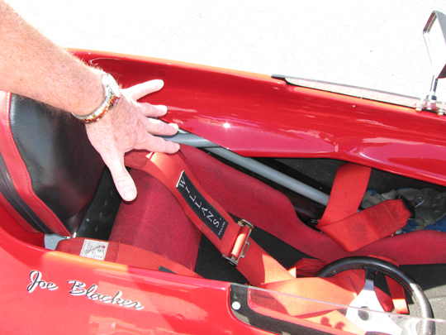
A close inspection of the cars did reveal one new truth: If one is bigger than size 40, the BT29 will be a very tight fit. The earlier, but competitive, BT21 has a wider cockpit opening at the shoulders. Make mine a BT21.

I watched the qualifying race on Saturday. SVRA was trying standing starts for the formula cars, as they would have seen in 1970. In the race, the top 5 FB cars ran in a pack and exchanged positions often. Lap times were around the two-minute mark. My DSR is several seconds faster at VIR, but it has lot of aero compared to the ole cigars. A gaggle of FB’s makes wonderful sounds.

Bottom line. Spend a bunch more to buy a car and to operate it in terms of tires and engine rebuilds. In return, get triple the track time, little petty bureaucracy, better tracks and events, diminishing disparity of entry fees, AND growing value of racing rolling stock. My house has nearly tripled in value over the past five years, so I can afford this, RIGHT?



